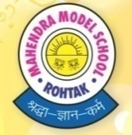
Mahendra Model School
Class -VI
Holidays’ Home Work-2019-20

English
- Find out all the nouns from lesson1 and 2 and write their meanings
- Find out all the verbs from lesson 3 and 4 and write their meaning.
- write daily 5- lines of handwriting for 20 days.
- Learn and write word-meaning and Q/A from textbook of Lesson- 1, 2, 3 and 4.
- Read any Panchantra story and write in your own words what you have understood
- Write the meanings of these words and stick colorful pictures
Hamper
Elf
Astronaut
Space shuttle
Eaves
Wrinkled
Ignoramus
Nintendo
Pitcher
Procession
Axe
Waterfall
Kneeling
Emperor Pilot
7. Write the names of 15 animals. write the names of their young ones,Cries and Dwellings . 8. Collect 10 collective nouns. write them and stick pictures

HINDI
1. पंद्रह दिन समाचार पत्र से दिनांक के अनुसार एक सुलेक लिखिये।
2. स्वर्नाम की परिभाषा लिखते हुए इसके भेदों सहित सुंदर सा चार्ट बनाइये।
3. Learn P.T 1 syllabus as mentioned in school diary

MATHS
Q.1:- Learn and write tables 2 to 25 (4 times) Q.2:- Do Model Test paper 1 (page no. 219-220)
Q.3:- Do given assignment.
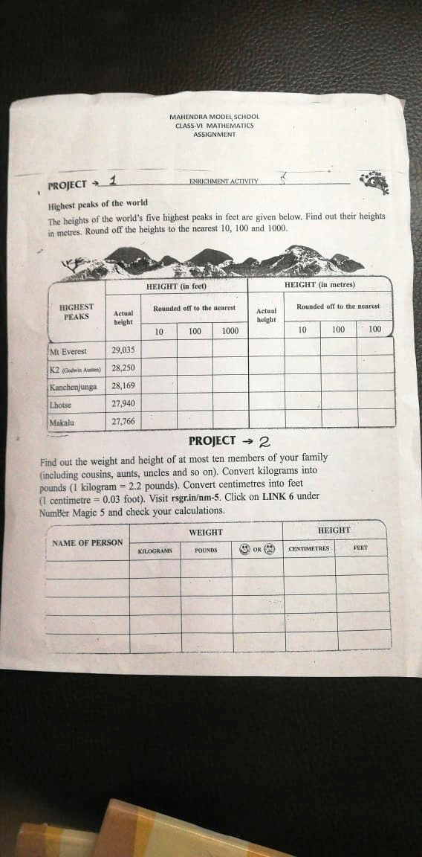
Q.4:- Write the total number of prime numbers from : (i) 1 to 100 (ii) 100 to 200 (iii) 200 to 300 on a chart.
SCIENCE
Q.1:- Collect the pictures of sources of food by plants and by animals. and Paste them in a scrap book with their names.
Q.2:- Make a chart of {table 2.3}importance of vitamins in our body.

OR
Make a chart of some important minerals in our daily meals.{page no.23} Q.3:- Collect natural and man-made fibres and paste them in a scrapbook. Write Two characteristics or properties of each type of fibre.
Q.4:- Learn keywords and exercise and Q/A of L=1,2,3,7.

SOCIAL SCIENCE
Q.1:- Learn periodic 1 syllabus.
Q.2:- Project work :- Prepare a model of the earth using a ball.
Mark the following on it :-
- The parallels of latitude.
- The meridians of longitude.
- The heat zone.
संस्कृत

पाठ-1,2 अकारान्त पुल्लिङ्गः, आक्रान्त-स्त्रीलिंङ्ग शब्दार्थ व
अभ्यास सहित लिखो व माद करो |

1 से 5०तक संस्कृत में गिनती लो व माद करो। पठ धातू लिखो व माद करो।

शरीर के अंगो नाम चार्ट पर चित्र सहित लिखो।
Music
Q.1:- Learn and write song- fulo ka taro…..
Q.2:- Learn and write National song in Notebook.
Q.3:- Learn and write : jyoti se jyoti…..

IT
Q.1:- Revise lesson 1 and 2.
Q.2:- Collect some information about the latest software in Practical NB.
Q.3:- Prepare a Chart on various format of a file.
GK
Q.1:- Learn Lessons 1 to 10.
Q.2:- Make a chart related to chapter 1 to 10 on anyone topic.
REASONING
Tick the correct answer :-
Q.1:- 713, 613, 513, 413, ₋₋₋₋₋₋₋₋₋₋₋
(a)317 (b)313 (c)213 (d)312
Q.2:- 1102, 1203, 1304, 1405, 1506, ₋₋₋₋₋₋₋₋₋₋₋
(a)1607 (b)1606 (c)1807 (d)1608

Q.3:- A,D,G,J, ---------
(a)Q (b)H (c)N (d)P
Q.4:- ABZ, CDY, EFX, GHW, ₋₋₋₋₋₋₋₋₋₋
(a)JVJ (b)IJV (c)IKL (d)IPL
Q.5:- A10,B20,C30,D40,E50,₋₋₋₋₋₋₋₋₋ (a)F60 (b)G60 (c)H60 (d)F70
FIND THE ODD ONE OUT:
Q.6:- (a) Fan (b) Cooler (c) Fridge (d) Air Conditioner
Q.7:- (a) Bake (b) Peel (c) Fry (d) Roast
Q.8:- (a) Calendar (b) Year (c) Date (d) Month
ARRANGE IN MEANINGFULL SEQUINCE :
Q.9:- 1. Table 2. Tree 3. Wood 4. Seed 5. Plant
(a) 4,5,3,2,1 (b) 4,5,2,3,1 (c) 1,3,2,4,5 (d) 1,2,3,4,5
Q.10:- 1.College 2.Child 3. Salary 4. School 5. Employment
(a) 1,2,4,3,5 (b) 2,4,1,5,3 (c) 4,1,3,5,2 (d) 5,3,2,1,4
Q11.Tick the odd one out:
(i) Bake , Peel , Fry , Boil , Roast
(ii) Hat , Cap , Veil , Turban , Helmet
(iii) Square , Cube , Rectangle , Circle , Rhombus
(iv) 43 , 53 , 63 , 73 , 83
(v) 51 , 144 , 64 , 121 , 256
Q12..Draw the mirror image of the following words:
(i) DELHI
(ii) EAGLE
(iii) ZIPPER
(iv) PENCIL

If + means x, - means ÷, × means + and ÷ means -, then determine the following:-
Q.13:- 2+3×6÷12-4= ?
Q.14:- 14-7×2÷1+3=?
Q.15:- 24-4+2÷5×2=?
Q.16:- 9×7÷3+14-7=?
Answer the following question:
Q.17:- If 2*3=6 and 3*4=12, then 7*8= ?
Q.18:- If 35#5=7 and 48#8=6, then 100#25= ?
Q.19:- How many C’s are there in the following sequence, which are immediately followed by D ?
ABDCDCCDCLCDDCBDCCD
(a)Two (b) Three (c) Four (d) Five
Q.20:- if Tuesday falls on the first of a month, then which day will Fall Three days after 12th ?
(a) Saturday (b) Friday (c) Sunday (d) Tuesday
ART
Q:- Make Model with waste Material on thermacol anything

NOTE : SCHOOL WILL REMAIN CLOSED FOR SUMMER VACATION FROM 29.05.2019 TO
02.07.2019 SCHOOL WILL REOPEN ON 03.07.2019

Note: You can see/ Download from school website : www.mahendramodelschoolrtk.co.in
Downloads Holidays homework Class Enter

