Mahendra Model School
Holidays’ Home Work
Class XII θ
English:-
- Write any five Job applications for three different Jobs
- Write and learn value based questions of the chapters done in the class.
- Learn questions of L 1 & 2 from book “Flamingo” also Lesson 1 & 2 from book “Vistas”
- Write articles on the following Topics:-
- Demonitisation.
- Global warming.
- Importance of Culture and Tradition in our life.
Mathematics:-
Do full exercises of chapters from NCERT and Elements:-
- Matrix
- Determinants
- Continuity
- Differentiation
Pol. Science:-
- Do exercises of chapters 1,2and 3
- Map Work:- a. Locate any five members of USSR Block in pol. world map.
b. Locate any 5 members of NATO in pol. world map.
c. Locate countries involved in Cuban missile crisis in political world map and also write down their leader
d. Locate 5 founder nations of NAM and also write the names of leaders.
Hindi:- Do the given assignment.
History:-Do the given assignment.
Geography:- Do the given assignment.
Music:- कक्षा में किया गया कार्य याद करें।
क निम्नलिखित की परिभाषा लिखें :-
अलंकार ,वर्ण ,कण ,खटका ,मुरकी , गमक ,ग्राम ,मूर्छना ,अलाप और तान।
ख रगों के समय सिद्धांत का वर्णन कीजिए।
ग रागों के वर्गीकरण का वर्णन कीजिए।
Physical Education:-
- Prepare Practical File.
- Learn and write Q/Ans. Of chapter 1st 2nd and 3rd .

Hindi Assignment
Class XII θ
1. निम्नलिखित निबंध लिखिए :-
१. वर्षा की एक भयानक रात
२. चलचित्र के लाभ व हानि
३. बढ़ती जनसंख्या एक भयानक समस्या
४. रुपए को मिला नया प्रतीक चिन्ह
५. कश्मीर समस्या
2. निम्नलिखित पत्र लिखिए :-
१. आप के क्षेत्र में आभूषण झपटमारी की घटनाएं दिन - प्रतिदिन बढ़ती जा रही है। इसकी शिकायत करते हुए अपने क्षेत्र के पुलिस अधीक्षक को पत्र लिखिए।
२."सर्वोदय बाल विद्यालय रॉउज़ ऐवनयू " में शारीरिक शिक्षक का एक पद रिक्त है। विज्ञापन के अनुसार अपनी योग्यता का विवरण प्रस्तुत करते हुए शिक्षा निर्देशक कोआवेदन पत्र प्रस्तुत कीजिए।
३.सार्वजनिक सूचना -पट्टो पर लिखी अशुद्ध हिंदी की ओर ध्यान आकृष्ट करते हुए किसी दैनिक समाचार पत्र के संपादक को पत्र लिखिए।
3. दूरदर्शन न्यूज़ और कोई एक निजी समाचार चैनल जैसे आज तक ,स्टार न्यूज़ आदि के रात 9 बजे के बुलेटिन एक दिन का अंतर देकर लगातार दो सप्ताह तक लिखिए। जैसे एक दिन डीडी न्यूज़ देखिए तो अगले दिन कोई निजी समाचार चैनल। दोनों के समाचार बुलेटिन के कलेवर और प्रस्तुति की तुलना करते हुए 200 शब्दों की रिपोर्ट तैयार कीजिए।
4. विभिन्न जन संचार माध्यमों -प्रिंट ,रेडियो ,टेलीविज़न ,इंटरनेट से जुडी पाँच -पाँच खूबियों और खामियों को लिखते हुए एक तालिका तैयार करें।
History- Assignment
- Make a project report on the following topics: -
- Town Planning and Artefacts of the Harappan Civilization. (Group A students)
- Mahabharata through the reader’s eye. (Group B students)
- Through the Travelers’ eye. (Group C students)
- Understanding the Bhakti-Sufi Movement in India. (Group D students)
- Depiction of life during Mughal period through paintings. (Group E students)
- The partitions of India in 1947 and its effects on common people. (Group F students)
- Learn 1st periodic syllabus.
- Answer the following questions in your history notebook: -
- In your opinion, why is the script of Harappan Culture considered mysterious or enigmatic? State the main features of this script.
- Describe how artefacts help in identifying social differences during the Harappan period.
- “The most unique feature of Mohenjodaro was the planned urban centre.” Support the statement with examples.
- Describe the economic life of the Harappan people.
- Describe the religious beliefs of the Harappan people.
- Explain trade relations of Harappa with Western Asia.
- Give brief description of the Great Bath of Mohenjodaro.
- How did the Harappan civilization decline?
- Discuss the functions that may have been performed by rulers in Harappan society.
- Why was the first site of Harappa badly destroyed?
- What is Manusmriti? What advice has been given to the king in it?
- Who was the Prabhavati Gupta? Tell a rare example found about her.
- Describe in your own words the story of the rise of Magadha state.
- Describe briefly about the sources of Mauryan history.
- Name any four inscriptions of Ashoka. Also write where they are situated.
- How Ashoka propagated and spread Buddhism?
- How was Kharosthi script read?
- List some of the problems faced by epigraphists.
- What was the Varna System? What were the ideal the occupations for each Varna?
- Write a note on Shakas.
- Who was Gotami-Puta Satakani? Describe his main achievements.
- What was the relation between Varna and property?
- Describe the position of the untouchables in Ancient Society.
- What is Mahabharata? How its critical edition was prepared?
- Describe the rules of marriage during the period of c. 600 BCE - 600 CE.
- Map work: -
- Page no. 2 (NCERT) - Mature Harappan sites: Harappa, Banawali, Kalibangan, Balakot, Rakhigadi, Dholavira, Nageshwar, Lothal, Mohenjodaro, Chanhudaro and Kot Diji.
- Page no. 30 (NCERT) - Mahajanapada and cities: Vajji, Magadha, Koshala, Kuru, Panchala, Gandhara, Avanti, Rajgir, Ujjain and Taxila.
Practical Work ( practical file syllabus)
Unit I : Processing of Data and Thematic Mapping (Periods 20)
Sources of data.
Tabulating and processing of data; calculation of averages,measures of central tendency, deviation and rank correlation;
Representation of data- construction of diagrams: bars, circles and flowchart; thematic maps; construction of dot; choropleth and isoplethmaps.
Use of computersin data processing andmapping.
Unit II: Field Study or Spatial Information Technology (Periods 10)
Field visit and study: map orientation, observation and preparation ofsketch;survey on any one of the local concerns; pollution, ground water changes, land use and land-use changes, poverty, energy issues, soil degradation, impact of floods and drought, catchment area of school, Market survey and Household survey (any one topic of local concern may be taken up for the study; observation and questionnaire survey may be adopted for the data collection; collected data may be tabulated and analysed with diagrams andmaps).
OR
Spatial InformationTechnology
Introduction to GIS; hardware requirements and software modules; data formats; raster and vector data, data input, editing&topologybuilding; data analysis; overlay&buffer.

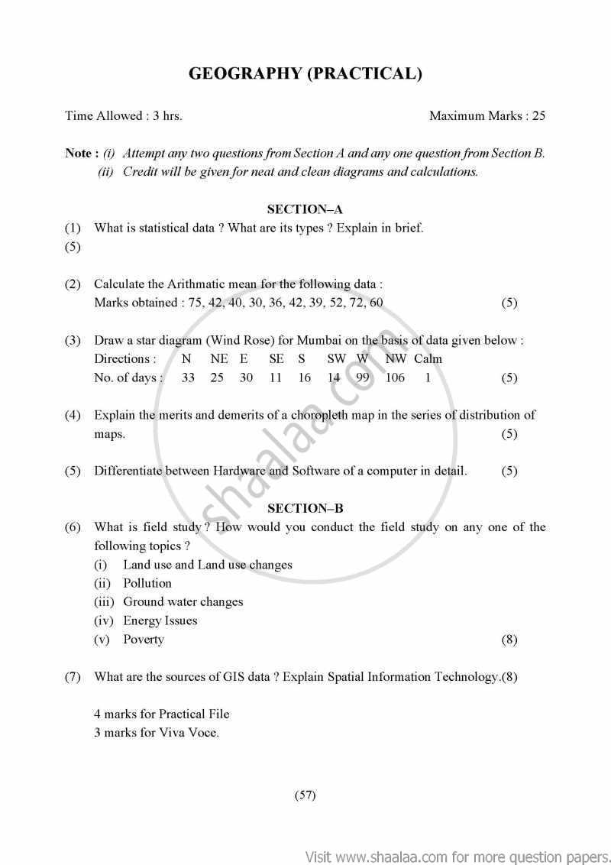

GEOGRAPHY PRACTICAL PAPER-2
CLASS – XIIth
AISSE EXMINATION

Q1- The following table gives rainfall figures of a place. Calculate the arithmetic mean through direct method.
निम्नलिखित सारणी में किसी स्थान की वर्षा के आंकड़े दिए गए है। अंकगणितीय मध्य ज्ञात कीजिये। प्रत्यक्ष विधि के माध्यम से।

Rainfall(in mm) | 30-35 | 35-40 | 40-45 | 45-50 | 50-55 | 55-60 | 60-65 | 65-70 | 70-75
No. of days | 5 | 6 | 11 | 18 | 19 | 15 | 13 | 1 | 2

Q2- Show the following data by bar diagram.
निम्न आंकड़ो को दंड आरेख द्वारा प्रदर्शित करे ।
Months | J | F | M | A | M | J | J | A | S | O | N | D
Rainfall | 2.51 | 2.11 | 0.29 | 0.84 | 1.34 | 7.70 | 17.86 | 18.36 | 12.29 | 1.02 | 0.25 | 1.09

Q3- Draw a star diagram of new Delhi using the following data. निम्नलिखित आंकड़ो से नई दिल्ली का तारा आरेख बनाइए ।
Direction of wind | N | NE | E | SE | S | SW | W | NW | CALM
No. of days | 33 | 22 | 24 | 29 | 17 | 16 | 102 | 101 | 21

Q4- What is questionnaire method ? Compare semantic scale questions and open ended questions.
प्रश्नावली विधि किसे कहते है ? क्रम मापक उत्तर के प्रश्न तथा मुक्तांत उत्तर प्रश्नो की तुलना करें।
Q5- Field survey : Any one case study
कोई क्षेत्रीय सर्वेक्षण:एक चयनित अध्ययन
1) प्रदुषण (pollution)
2) गरीबी (Poverty)
3) मृदा ह्रास (Soil degradation)
GEOGRAPHY PRACTICAL PAPER-3
CLASS – XIIth
AISSE EXMINATION

1. The following data shows India’s total population (in millions) from 1951 to 2001. Find the arithmetic mean by direct method.
Year of Census | 1951 | 1961 | 1971 | 1981 | 1991 | 2001
Population (in millions) | 360 | 432 | 542 | 684 | 852 | 1020

2. Q2- Show the following data by bar diagram.
निम्न आंकड़ो को दंड आरेख द्वारा प्रदर्शित करे ।
Months | J | F | M | A | M | J | J | A | S | O | N | D
Rainfall | 3 | 5 | 4 | 0.44 | 2.34 | 7 | 7.86 | 8.36 | 1.9 | 2 | 15.6 | 3.09

Q3- Draw a star diagram using the following data. निम्नलिखित आंकड़ो से तारा आरेख बनाइए ।
Direction for Tally | Frequency | Percentage
N | 155 | 22.3%
NE | 100 | 14.4%
E | 36 | 5.2%
SE | 18 | 2.6%
S | 61 | 8.8%
SW | 75 | 10.8%
W | 62 | 8.9%
NW | 189 | 27.2%
Total | 696 | 100%

4. What do you mean by processing of data? What are two main sources of secondary data?

5. List the tools and techniques used during a field survey. CASE STUDY: ( choose any one )
(A) Soil Degradation
(B) Floods
(C) Energy Issues

GEOGRAPHY PRACTICAL PAPER-4
CLASS – XIIth
AISSE EXMINATION

Q1- The following table gives rainfall figures of a place. Calculate the arithmetic mean through direct method.
निम्नलिखित सारणी में किसी स्थान की वर्षा के आंकड़े दिए गए है। अंकगणितीय मध्य ज्ञात कीजिये। प्रत्यक्ष विधि के माध्यम से।

Rainfall(in mm) | 10-15 | 15-20 | 20-25 | 25-30 | 30-35 | 35-40 | 40-45 | 45-50 | 50-55
No. of days | 2 | 9 | 10 | 12 | 17 | 13 | 8 | 10 | 9

Q2- Show the following data by bar diagram.
निम्न आंकड़ो को दंड आरेख द्वारा प्रदर्शित करे ।
Months | J | F | M | A | M | J | J | A | S | O | N | D
income | 2500 | 2110 | 2900 | 8400 | 1340 | 1770 | 1780 | 1830 | 1200 | 1000 | 2500 | 1900

Q3- Draw a star diagram of new Delhi using the following data. निम्नलिखित आंकड़ो से नई दिल्ली का तारा आरेख बनाइए ।
Direction of wind | N | NE | E | SE | S | SW | W | NW | CALM
No. of days | 37 | 29 | 16 | 29 | 17 | 16 | 76 | 109 | 23

Q4. What are statistical diagrams? What is the importance of statistical diagram in geography? What are the drawbacks of statistical diagrams?

Q5. What type of coverages need to defined before undertaking a field survey? CASE STUDY: ( choose any one )
(A) Floods
(B) Energy Issues
(C) Land Use Change Detection

GEOGRAPHY PRACTICAL PAPER-5
CLASS – XIIth
AISSE EXMINATION

Q1- The following table gives rainfall figures of a place. Calculate the arithmetic mean through direct method.
निम्नलिखित सारणी में किसी स्थान की वर्षा के आंकड़े दिए गए है। अंकगणितीय मध्य ज्ञात कीजिये। प्रत्यक्ष विधि के माध्यम से।

Rainfall(in mm) | 30-40 | 40-50 | 50-60 | 60-70 | 70-80 | 80-90 | 90-100 | 110-120 | 120-130
No. of adays | 30 | 34 | 22 | 28 | 18 | 22 | 23 | 19 | 29

Q2- Show the following data by bar diagram.
निम्न आंकड़ो को दंड आरेख द्वारा प्रदर्शित करे ।
Months | J | F | M | A | M | J | J | A | S | O | N | D
Expenditure on food | 230 | 300 | 290 | 440 | 340 | 770 | 750 | 360 | 290 | 102 | 250 | 490

Q3- Draw a star diagram of new Delhi using the following data. निम्नलिखित आंकड़ो से नई दिल्ली का तारा आरेख बनाइए ।
Direction of wind | N | NE | E | SE | S | SW | W | NW | CALM
No. of days | 28 | 22 | 42 | 24 | 26 | 19 | 92 | 103 | 24

Q4. What are Flow diagrams? What are the two important features of flow diagram?

Q5. Why is the well-structured questionnaire important for a field survey ? CASE STUDY: (choose one)
(a) Environmental Pollution
(b) Soil Degradation
(c) Floods

